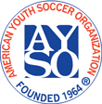 |  | Sponsored by AYSO Region 678, Newhall/Valencia, California  2019 AYSO Santa Clarita Gold Rush  Referee Information Form |  |  |  |  |  |  |  |  |  |  |  |  |  |  |  |  |  |  | 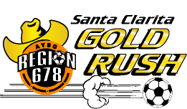
I plan to bring a referee team to the tournament Y/N: |  |  |  |  |  |  |  |  |  |  |  |  | Referee Information Form Date:
Region: |  |  |  |  | Team Name:

Coach Name:
Age Division (circle): |  |  |  | 9U |  | 10U | 11U |  | 12U | 13U | 14U |  |  |  |  |  |  |  | Boys |  |  |  |  | Girls |  | Coed

Referee Team Contact Person
Name: |  | Email Address:
Day Phone: |  | Evening Phone:
Provide the following information for each referee.
- For “Badge Level”, insert R = Regional, I = Intermediate, A = Advanced, N = National.

 | Referee Name | Badge Level | Highest level qualified/comfortable refereeing (age, B/G) | Player on Team (Y/N) | Cell Phone/ Email
1
2
3

Note: Any Youth Referee on this team will be required to carry with them a signed Youth Referee Letter Form.

Each referee will receive a tournament T-Shirt. Please indicate sizes needed. All sizes are Adult.
 | XXL | XL |  | L |  | M | S
Number of Shirts Needed
Regional Referee Administrator’s Name |  |  |  |  | Phone Number |  |  |  |  | Email
By my signature below, I certify that all referees listed are certified AYSO referees and qualified for officiating 10U through 14U games as indicated above.
RRA Signature or Regional Commissioner and date (Blue ink please)
Area Referee Administrator’s Name |  | Phone Number |  | Email

